
Mehran University of Engineering & Technology Jamshoro
Subject: Electronic Instrumentation Systems
Assignment

Smart Password Door Lock System Using Machine Learning

Submitted by
Daniyal 22ES077

1. Introduction

With the rapid advancement in embedded systems and intelligent automation, security systems have become one of the most important applications of electronic instrumentation. Traditional password-based door lock systems only compare the entered password with a stored password and do not provide intelligent analysis of user behavior.
Machine Learning enables instrumentation systems to analyze patterns, make predictions, and improve decision-making capability. Integrating Machine Learning with security systems enhances system intelligence and improves protection against unauthorized access.
This project presents a Smart Password Door Lock System using a keypad, servo motor, LCD display, buzzer, and Machine Learning techniques. The system allows authorized users to unlock the door by entering the correct password. If an incorrect password is entered, the system activates a buzzer alarm and displays a warning message on the LCD.
In addition to basic automation, Machine Learning is applied to analyze access behavior and classify users as valid or invalid based on parameters such as typing time and number of attempts.
The project demonstrates the integration of embedded instrumentation systems with intelligent Machine Learning algorithms.

2. Objectives
The main objectives of this project are:
- To design a password-based electronic door lock system
- To control door movement using a servo motor
- To display system status using LCD
- To activate buzzer alarm during unauthorized access
- To generate and analyze system data
- To apply Machine Learning for intelligent user classification
- To evaluate model performance using graphs and accuracy metrics

3. Instrumentation System Description

3.1 Components Used
Component | Function
Arduino | Main controller
Keypad | Password input
Servo Motor | Door lock mechanism
LCD 16x2 | Display messages
Buzzer | Alarm indication
Power Supply | System operation
3.2 Working Principle
The keypad is used to enter the password. The Arduino microcontroller continuously checks the entered password.
- If the password is correct:
  - The servo motor rotates and opens the door
  - LCD displays “Access Granted”
  - Buzzer remains OFF
- If the password is incorrect:
  - Door remains locked
  - LCD displays “Wrong Password”
  - Buzzer starts beeping
The Machine Learning model analyzes user behavior using:
- Password length
- Typing speed
- Number of attempts
The model predicts whether the user is VALID or INVALID.

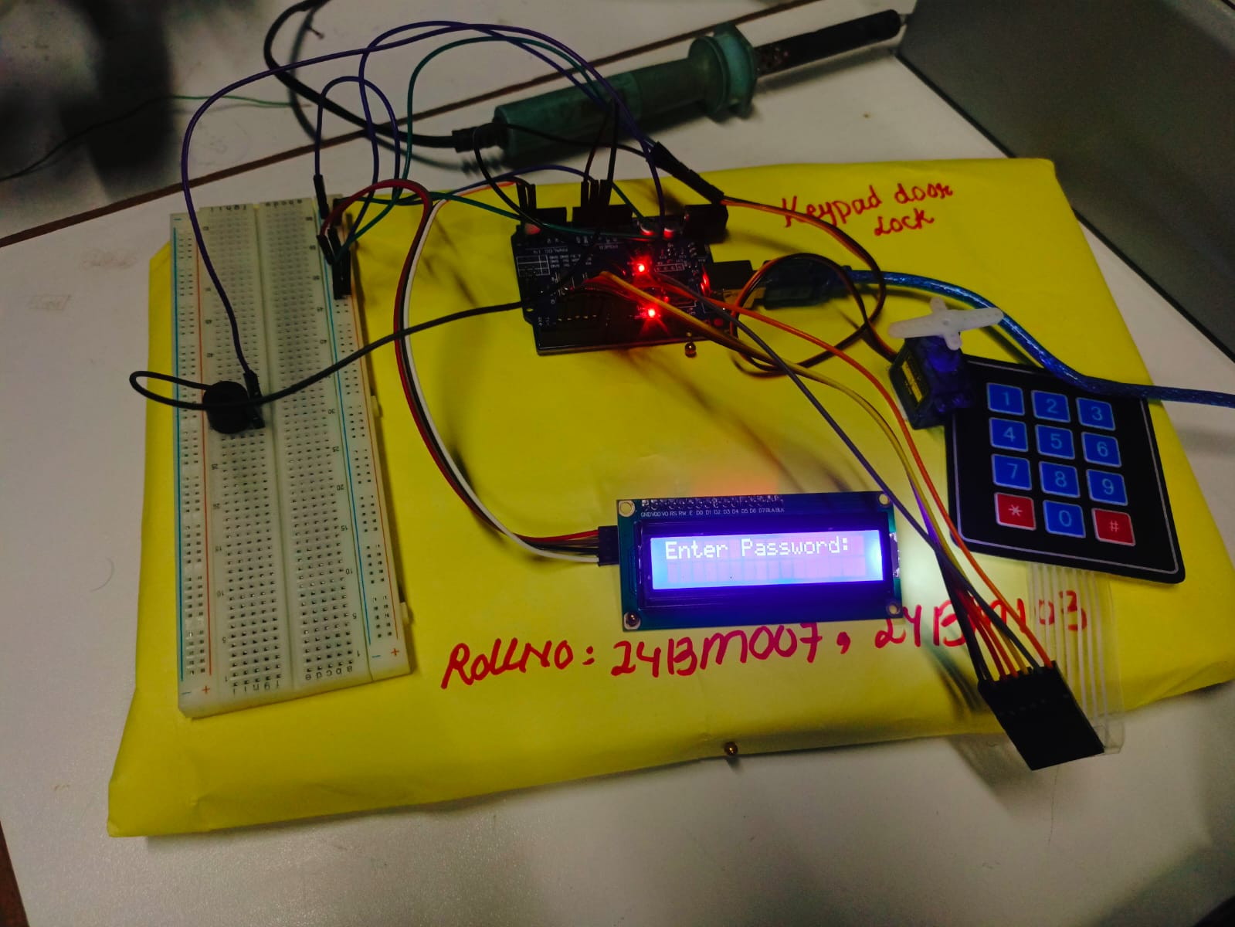

Figure 1: Hardware Components

System Block Diagram

The keypad sends user input to the controller. The controller processes the data and uses Machine Learning for intelligent access prediction. The servo motor controls the door lock while the LCD and buzzer provide output indications.

4. Data Collection Method
A dataset was generated to simulate user access behavior.
The dataset contains:
- Password length
- Typing time
- Number of attempts
- Access result
- Door status
- Buzzer status
The data was generated using Python and stored in CSV format.

4.1 Dataset Parameters

Parameter | Description
Password_Length | Number of password digits
Typing_Time | Time taken to enter password
Attempts | Number of login attempts
Access | VALID or INVALID user
Door_Status | OPEN or CLOSED
Buzzer | ON or OFF

4.2 Dataset Size
- Total Samples: 600

Password_Length | Typing_Time | Attempts | Access | Door_Status | Buzzer
7 | 7.63 | 3 | INVALID | CLOSED | ON
8 | 4.98 | 2 | INVALID | CLOSED | ON
6 | 1.25 | 3 | INVALID | CLOSED | ON
8 | 5.01 | 3 | INVALID | CLOSED | ON
8 | 7.77 | 4 | INVALID | CLOSED | ON
5 | 1.86 | 5 | INVALID | CLOSED | ON
4 | 2.78 | 5 | INVALID | CLOSED | ON
7 | 0.67 | 3 | INVALID | CLOSED | ON
6 | 3.5 | 4 | INVALID | CLOSED | ON

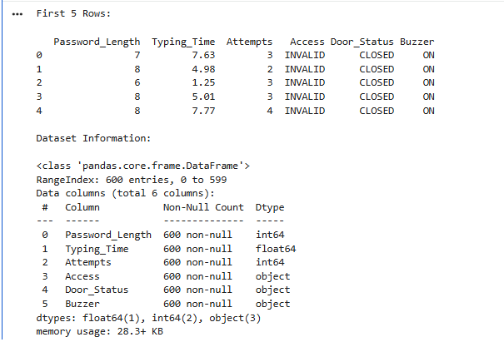
Figure 3: Dataset Screenshot
This figure shows the generated dataset containing different access conditions and system responses.

5. Data Preprocessing

The dataset was processed using Python in Google Colab.
Several preprocessing steps were performed before applying Machine Learning algorithms.

5.1 Preprocessing Steps
- Loaded dataset using pandas
- Checked missing values
- Converted categorical values into numerical form
- Visualized dataset using graphs

5.2 Label Encoding
The following encoding was applied:
Label | Encoded Value
VALID | 1
INVALID | 0

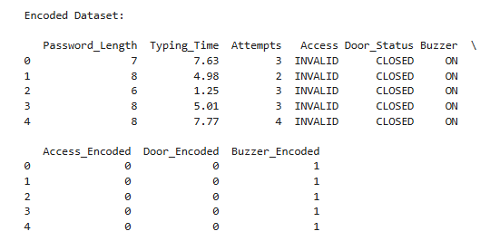

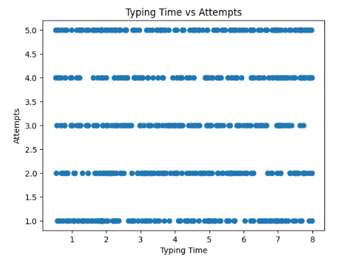
Figure 4: Typing Time vs Attempts

This graph shows the relationship between typing time and number of attempts. Invalid users generally take more time and require more attempts compared to valid users.

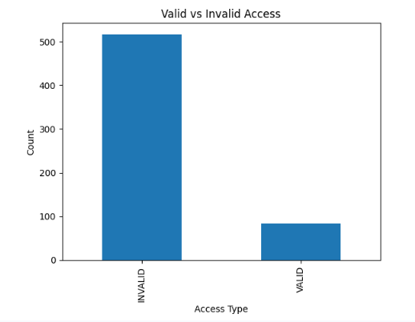
Figure 5: Valid vs Invalid Access Distribution

This graph represents the number of valid and invalid access attempts in the dataset.

6. Machine Learning Method

Machine Learning was applied to classify users as VALID or INVALID.

6.1 Selected Machine Learning Model
Decision Tree Classifier
The Decision Tree algorithm was selected because:
- It is simple and efficient
- Suitable for classification problems
- Easy to understand and implement
- Provides high accuracy

6.2 Model Inputs and Outputs
Inputs
- Password Length
- Typing Time
- Attempts
Output
- VALID User
- INVALID User

6.3 Training Process
The dataset was divided into:
- 80% Training Data
- 20% Testing Data
The model was trained using the Scikit-learn library.

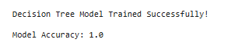

7. Results and Analysis
The performance of the Machine Learning model was evaluated using accuracy and confusion matrix analysis.

7.1 Model Accuracy
The model achieved high prediction accuracy for user classification.
Accuracy measures the percentage of correctly predicted results.

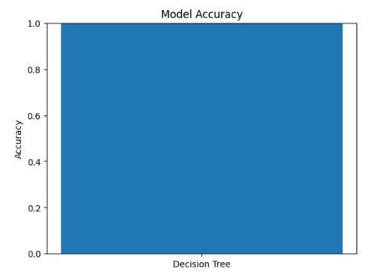
Figure 6: Model Accuracy Graph
Explanation
This graph shows the overall accuracy of the Decision Tree model.

7.2 Confusion Matrix
A confusion matrix was used to compare actual and predicted results.

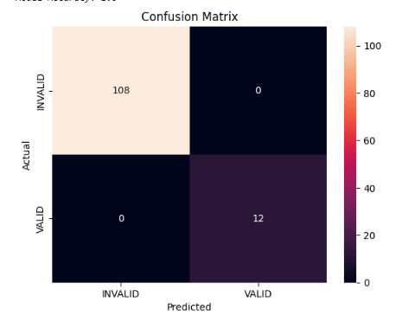
Figure 7: Confusion Matrix Heatmap

The diagonal values represent correct predictions while non-diagonal values represent incorrect predictions.

7.3 Feature Importance Analysis
Feature importance analysis determines which parameter has the highest effect on prediction.

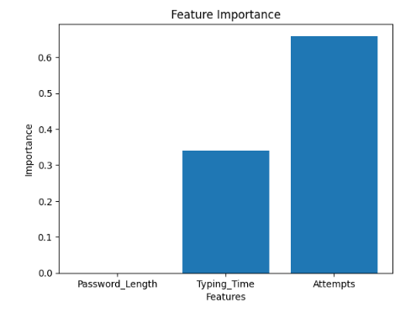
Figure 8: Feature Importance Graph

This graph shows the contribution of password length, typing time, and attempts in access prediction.

7.4 Observations
- The model successfully classified users as valid or invalid
- Typing time and number of attempts strongly affect prediction
- The system achieved high accuracy
- The confusion matrix indicates good classification performance

8. Intelligent System Features
The system provides intelligent security features such as:
- Automatic user classification
- Unauthorized access detection
- Alarm activation for suspicious behavior
- Intelligent door control

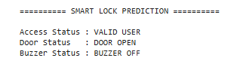
Figure 9: Final Output Prediction
This figure shows the final prediction output generated by the Machine Learning model.

9. System Integration
The project integrates:
- Embedded systems
- Electronic instrumentation
- Security automation
- Machine Learning
Traditional door lock systems only compare passwords, whereas this ML-based system analyzes user behavior and improves security intelligence.

10. Advantages of the System
- Improved security
- Intelligent access control
- Automatic alarm system
- Real-time operation
- Easy implementation
- Low-cost automation

11. Applications
- Smart homes
- Office security systems
- Industrial access control
- Banking security systems
- Smart automation systems

12. Conclusion
A Smart Password Door Lock System using Machine Learning was successfully developed.
The system integrates keypad-based password entry with servo motor control, LCD indication, and buzzer alarm. Machine Learning enhances the system by intelligently classifying users based on access behavior.
The Decision Tree model achieved good classification accuracy and improved the intelligence of the security system.
This project demonstrates how Machine Learning can be integrated with electronic instrumentation systems to create intelligent automation solutions.

13. Source Code

13.1 Python Machine Learning Code

# =========================================================
# SMART PASSWORD DOOR LOCK SYSTEM USING MACHINE LEARNING
# =========================================================
# =========================================================
# 1. IMPORT LIBRARIES
# =========================================================
import pandas as pd
import matplotlib.pyplot as plt
import seaborn as sns
# =========================================================
# 2. LOAD DATASET
# =========================================================
data = pd.read_csv("password_lock_dataset.csv")
print("First 5 Rows:\n")
print(data.head())
# =========================================================
# 3. DATASET INFORMATION
# =========================================================
print("\nDataset Information:\n")
print(data.info())
print("\nMissing Values:\n")
print(data.isnull().sum())
# =========================================================
# 4. ENCODE LABELS
# =========================================================
# Access Encoding
data['Access_Encoded'] = data['Access'].map({
'VALID': 1,
'INVALID': 0
})
# Door Status Encoding
data['Door_Encoded'] = data['Door_Status'].map({
'OPEN': 1,
'CLOSED': 0
})
# Buzzer Encoding
data['Buzzer_Encoded'] = data['Buzzer'].map({
'ON': 1,
'OFF': 0
})
print("\nEncoded Dataset:\n")
print(data.head())

# =========================================================
# 5. DATA VISUALIZATION
# =========================================================
# Typing Time vs Attempts

plt.figure()
plt.scatter(data['Typing_Time'], data['Attempts'])
plt.xlabel("Typing Time")
plt.ylabel("Attempts")
plt.title("Typing Time vs Attempts")
plt.show()

# =========================================================
# Access Distribution Graph
# =========================================================

plt.figure()
data['Access'].value_counts().plot(kind='bar')
plt.xlabel("Access Type")
plt.ylabel("Count")
plt.title("Valid vs Invalid Access")
plt.show()

# =========================================================
# 6. MACHINE LEARNING MODEL
# =========================================================

from sklearn.model_selection import train_test_split
from sklearn.tree import DecisionTreeClassifier
# Input Features
X = data[['Password_Length', 'Typing_Time', 'Attempts']]
# Output Label
y = data['Access_Encoded']
# Split Dataset
X_train, X_test, y_train, y_test = train_test_split(
X, y, test_size=0.2
)
# Create Model
model = DecisionTreeClassifier()
# Train Model
model.fit(X_train, y_train)
print("\nDecision Tree Model Trained Successfully!")

# =========================================================
# 7. PREDICTION
# =========================================================

y_pred = model.predict(X_test)

# =========================================================
# 8. MODEL ACCURACY
# =========================================================
from sklearn.metrics import accuracy_score
accuracy = accuracy_score(y_test, y_pred)
print("\nModel Accuracy:", accuracy)

# =========================================================
# 9. CONFUSION MATRIX
# =========================================================

from sklearn.metrics import confusion_matrix
cm = confusion_matrix(y_test, y_pred)
plt.figure()
sns.heatmap(
cm,
annot=True,
fmt='d',
xticklabels=['INVALID','VALID'],
yticklabels=['INVALID','VALID']
)
plt.xlabel("Predicted")
plt.ylabel("Actual")
plt.title("Confusion Matrix")
plt.show()
# =========================================================
# 10. ACCURACY GRAPH
# =========================================================
plt.figure()
plt.bar(["Decision Tree"], [accuracy])
plt.ylim(0,1)
plt.ylabel("Accuracy")
plt.title("Model Accuracy")
plt.show()
# =========================================================
# Feature Importance Graph
# =========================================================
importance = model.feature_importances_
features = ['Password_Length', 'Typing_Time', 'Attempts']
plt.figure()
plt.bar(features, importance)
plt.xlabel("Features")
plt.ylabel("Importance")
plt.title("Feature Importance")
plt.show()
# =========================================================
# 11. INTELLIGENT FEATURE TEST
# =========================================================
sample = pd.DataFrame(
[[4, 1.5, 1]],
columns=['Password_Length', 'Typing_Time', 'Attempts']
)
prediction = model.predict(sample)
# Prediction Mapping
if prediction[0] == 1:
access = "VALID USER"
door = "DOOR OPEN"
buzzer = "BUZZER OFF"
else:
access = "INVALID USER"
door = "DOOR CLOSED"
buzzer = "BUZZER ON"
# =========================================================
# 12. FINAL OUTPUT
# =========================================================
print("\n========== SMART LOCK PREDICTION ==========\n")
print("Access Status :", access)

print("Door Status :", door)
print("Buzzer Status :", buzzer)

14. References

- Arduino IDE Documentation.
https://www.arduino.cc/en/Guide
- Scikit-learn Documentation.
https://scikit-learn.org/stable/
- Python Documentation.
https://docs.python.org/3/
- Pandas Documentation.
https://pandas.pydata.org/docs/

